**Project Design Phase-II**

**Cloud deployment**

|  |  |
| --- | --- |
| **Date** | **02 November 2023** |
| **Github name** | **https://github.com/Nareshkumar2001/Naan-Mudhalvan-Salesforce** |
| **Project Name** | A CRM Application For Managing Loan App and Fraudulent Prevention |

**Cloud deployment**

Deploying your CRM application for managing loan applications and preventing fraudulent activities in the cloud offers several advantages, including scalability, flexibility, and cost-effectiveness. Here are the steps to deploy your CRM application in a cloud environment:

1. **Select a Cloud Service Provider**:
   * Choose a cloud service provider that aligns with your requirements. Popular options include Amazon Web Services (AWS), Microsoft Azure, Google Cloud Platform (GCP), and IBM Cloud. Consider factors such as geographical availability, pricing, and the specific services offered.
2. **Set Up Development and Testing Environments**:
   * Create separate development and testing environments in the cloud to allow your development team to work on the application without affecting the production environment.
3. **Design Cloud Architecture**:
   * Plan the architecture of your CRM application in the cloud. Consider aspects such as virtual machines, databases, load balancers, and networking components. Leverage cloud services like AWS Elastic Beanstalk, Azure App Service, or Google App Engine for Platform as a Service (PaaS) options, which simplify application deployment.
4. **Containerization**:
   * Containerize your application using technologies like Docker. Containers provide a consistent and efficient way to package and deploy your application components.
5. **Orchestration**:
   * Use container orchestration tools such as Kubernetes (if available on your chosen cloud provider) to manage the deployment, scaling, and monitoring of containers.
6. **Database Deployment**:
   * Deploy your chosen database system in the cloud. Consider cloud-managed database services like AWS RDS, Azure SQL Database, or Google Cloud SQL for simplified database management.
7. **Security Measures**:
   * Implement robust security measures, including firewalls, access control, and encryption for data in transit and at rest. Utilize cloud-native security features and services offered by your cloud provider.

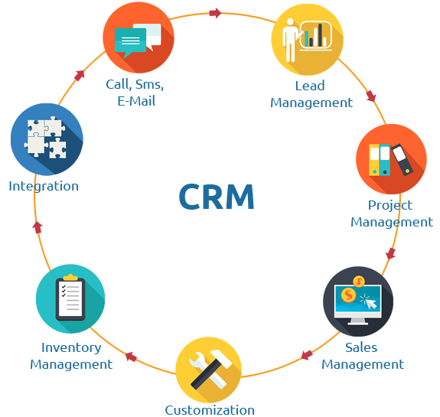

1. **Scalability**:
   * Leverage the auto-scaling capabilities of your cloud platform to handle varying loads efficiently. Configure scaling rules based on application usage.
2. **Data Backup and Disaster Recovery**:
   * Set up regular data backup and recovery procedures to ensure data integrity and availability. Cloud providers often offer backup and recovery services for databases and storage.
3. **Monitoring and Logging**:
   * Implement cloud-native monitoring and logging tools to track the performance and health of your CRM application. Services like AWS CloudWatch, Azure Monitor, and Google Cloud Monitoring can provide valuable insights.
4. **CD/CI Pipeline**:
   * Implement a continuous deployment and continuous integration (CD/CI) pipeline to automate the deployment process. Tools like Jenkins, GitLab CI/CD, and Travis CI can be used to build, test, and deploy your application.
5. **Load Balancing**:
   * Set up load balancers to distribute incoming traffic across multiple application instances for improved reliability and performance.
6. **Content Delivery Network (CDN)**:
   * Use a CDN to deliver static assets, such as images and documents, to users more quickly. Many cloud providers offer CDN services or integrate with third-party CDNs.
7. **Regulatory Compliance**:
   * Ensure that your CRM application hosted in the cloud complies with relevant regulations, such as GDPR, HIPAA, or industry-specific standards. Cloud providers often offer compliance certifications and services to assist with this.
8. **Cost Management**:
   * Regularly monitor and optimize your cloud usage to manage costs effectively. Cloud providers typically offer cost management tools and recommendations.
9. **Deployment Strategy**:
   * Plan your deployment strategy, which may include blue-green deployments or canary releases to minimize downtime and risks during updates.
10. **Backup Environments**:
    * Create staging and backup environments to test and verify new versions of your CRM application before rolling them out to the production environment.
11. **User Training and Documentation**:
    * Train your team on cloud deployment processes and ensure that you have comprehensive documentation for the deployed application and its infrastructure.

Deploying your CRM application in the cloud offers the flexibility to scale as needed, ensures high availability, and minimizes the need for managing on-premises hardware. However, it's crucial to continuously monitor and optimize your cloud resources to control costs and maintain a secure and performant application.

Top of Form